**DOKUMENTASI**

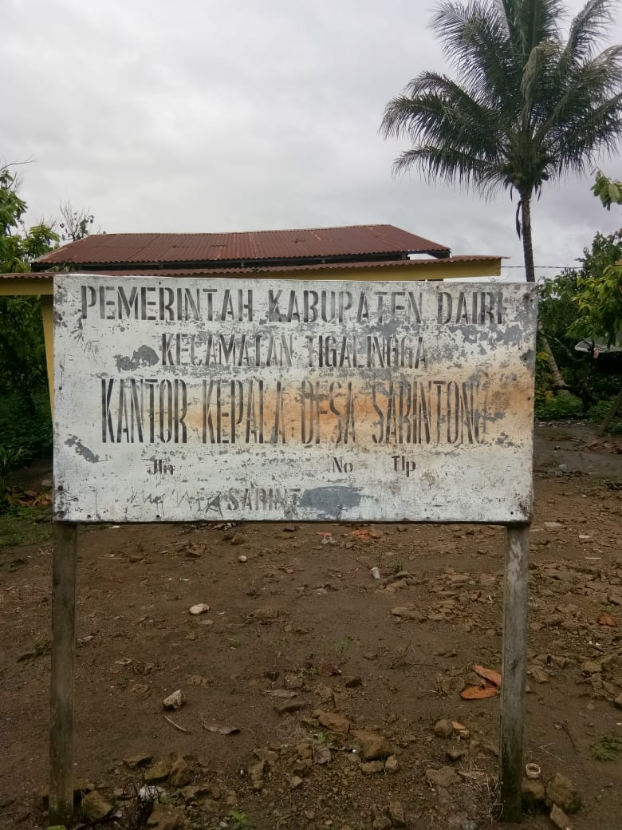

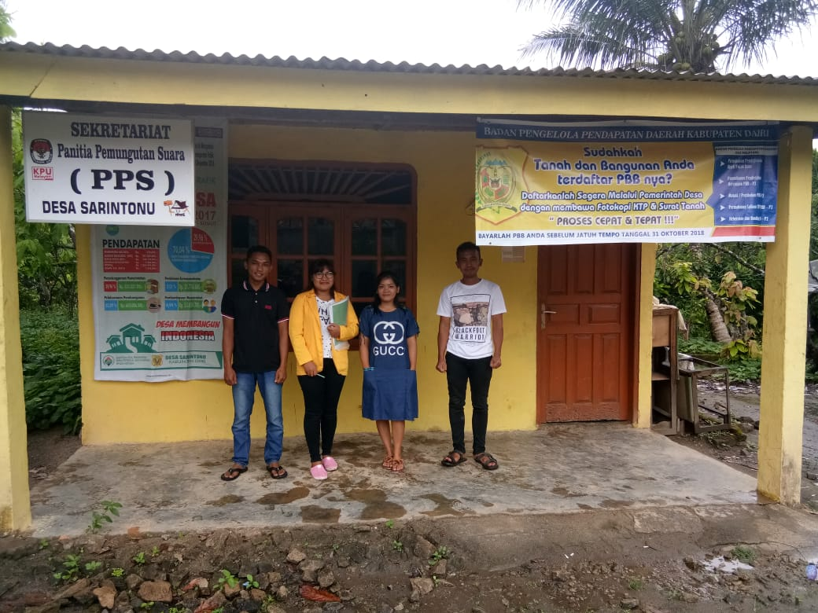

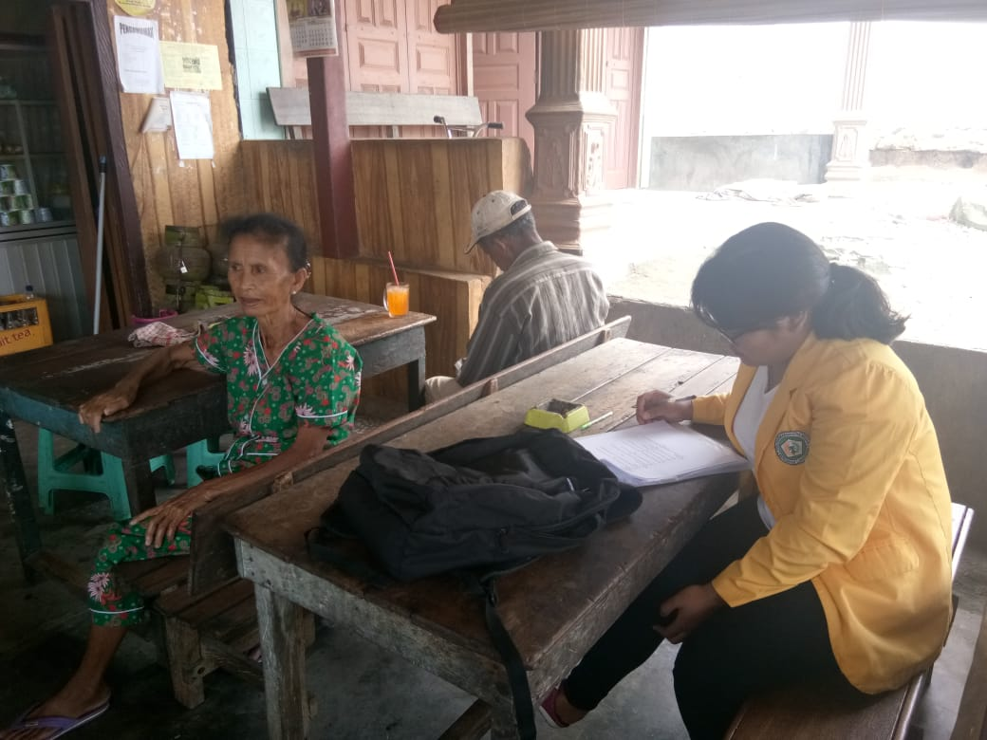

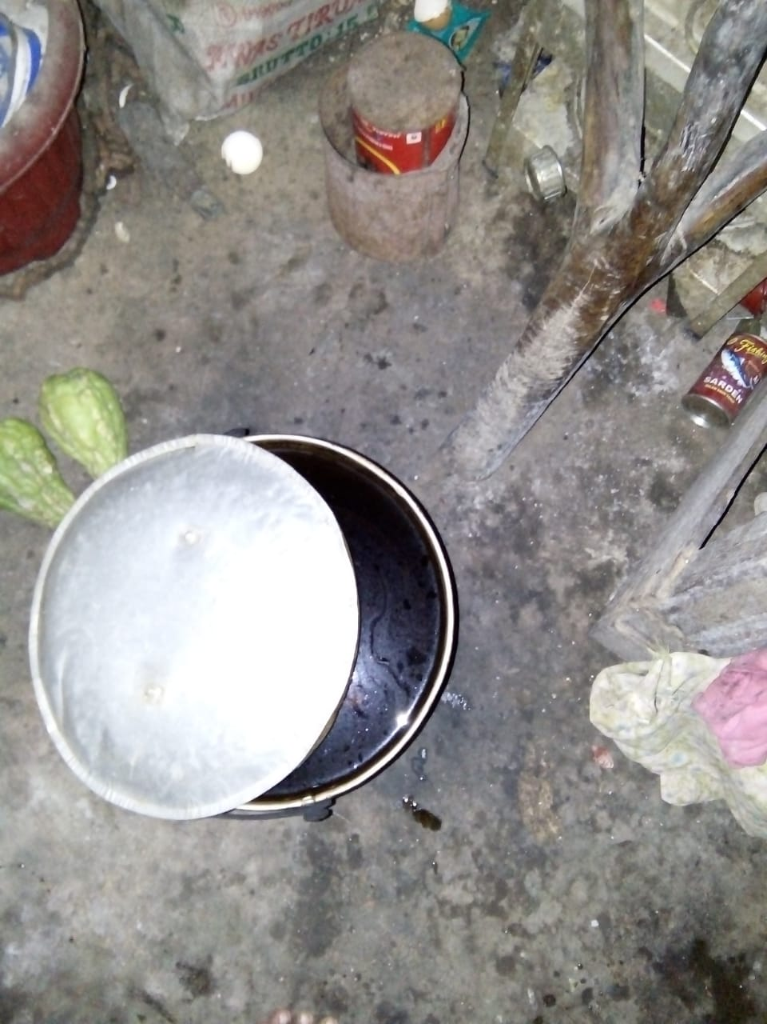

|  |  |
| --- | --- |
| C:\Users\WIN 10\AppData\Local\Microsoft\Windows\INetCache\Content.Word\IMG-20180810-WA0008.jpg | C:\Users\WIN 10\AppData\Local\Microsoft\Windows\INetCache\Content.Word\IMG-20180810-WA0002.jpg |

